**CS-114 - Fundamental of Programing**

Lab Manual # 08

**Course Instructor:** Khawaja Fahad Iqbal

**Lab Instructor:** Muhammad Affan

**Student Name:** Muhammad Talha Kashif

**CMS ID:** 454135

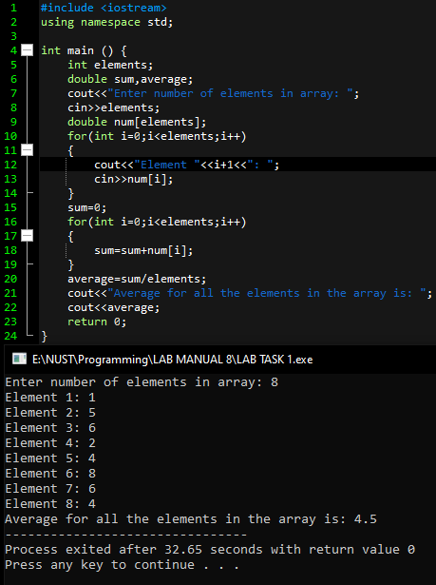

Lab Task 1

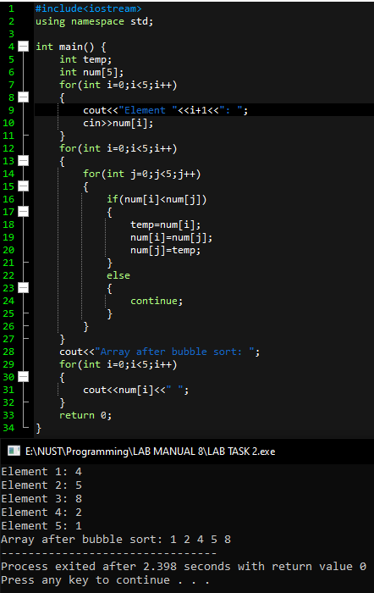

Lab Task 2

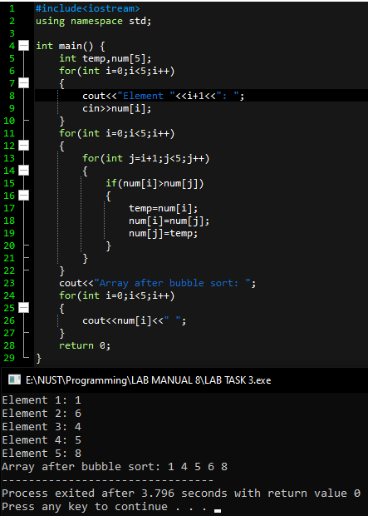

Lab Task 3